Experiment 2: Working with Maven: Creating a Maven Project, Understanding the POM File, Dependency Management and Plugins
Step 1: Open Your Terminal

Step 2: Use Maven Archetype to Generate a New Project
Maven comes with a set of archetypes that provide you with a standard project template. Use the following command to create a new Maven project:

mvn archetype:generate -DgroupId=com.example -DartifactId=MyMavenApp -DarchetypeArtifactId=maven-archetype-quickstart -DinteractiveMode=false

• groupId: Uniquely identifies your project’s group (like a package name).
• artifactId: The name of your project (the resulting artifact).
• maven-archetype-quickstart: A simple archetype that sets up a basic Java project with
a sample unit test.
• -DinteractiveMode=false: Runs the command in non-interactive mode, using the
provided parameters.

Step 3: Navigate to Your Project Directory
Once the command completes successfully, change your directory to the newly created project:

cd MyMavenApp
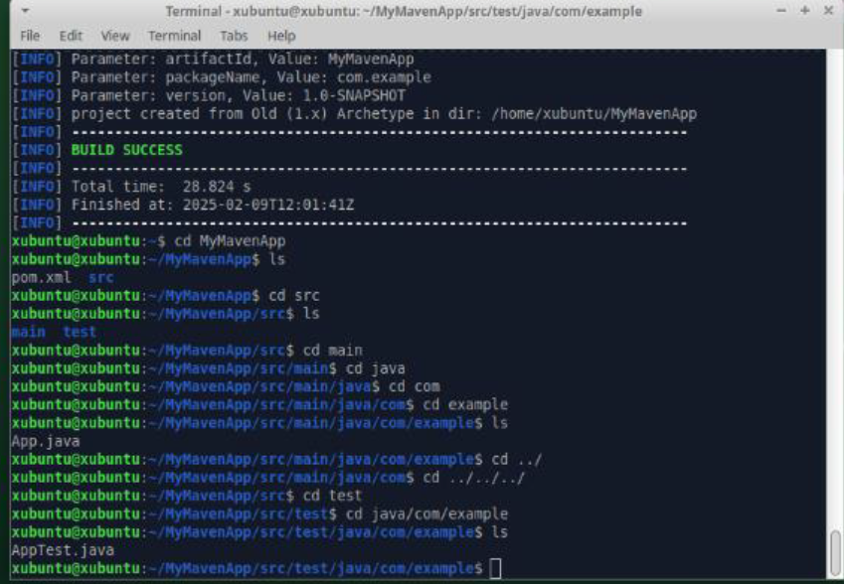

3. Maven Project Layout and Components
After generating the project, you will notice the following standard Maven directory structure:
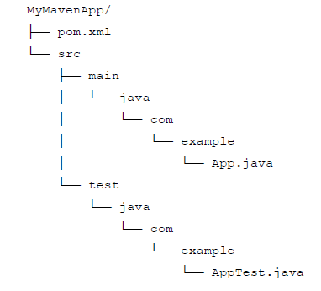

Explanation of Key Components
• pom.xml:
The Project Object Model (POM) file is the core of any Maven project. It contains
configuration details such as project coordinates (groupId, artifactId, version),
dependencies, plugins, and build settings.
• src/main/java:
This directory holds the source code of your application. In our example, the package
structure com.example is created, and you have an App.java file.
• src/test/java:
This directory is for your test cases. The default example includes a basic test class,
AppTest.java.

4. Understanding the POM File (pom.xml)
<project xmlns="http://maven.apache.org/POM/4.0.0" xmlns:xsi="http://www.w3.org/2001/XMLSchema-instance" xsi:schemaLocation="http://maven.apache.org/POM/4.0.0 http://maven.apache.org/xsd/maven-4.0.0.xsd"> <modelVersion>4.0.0</modelVersion>
<groupId>com.example</groupId>
<artifactId>MyMavenApp</artifactId>
<version>1.0-SNAPSHOT</version>
<properties>
<maven.compiler.source>11</maven.compiler.source> <maven.compiler.target>11</maven.compiler.target>
</properties>
<dependencies>
<dependency>
<groupId>junit</groupId>
<artifactId>junit</artifactId>
<version>4.13.2</version>
<scope>test</scope>
</dependency>
</dependencies>
<build>
<plugins>
<plugin>
<groupId>org.apache.maven.plugins</groupId>
<artifactId>maven-compiler-plugin</artifactId>
<version>3.8.1</version>
<configuration>
<source>11</source> <target>11</target> </configuration>
</plugin>
<plugin>
<groupId>org.apache.maven.plugins</groupId>
<artifactId>maven-surefire-plugin</artifactId>
<version>2.22.2</version>
</plugin>
</plugins>
</build>
</project>

Common Maven Commands
• Compile the Project:
mvn compile

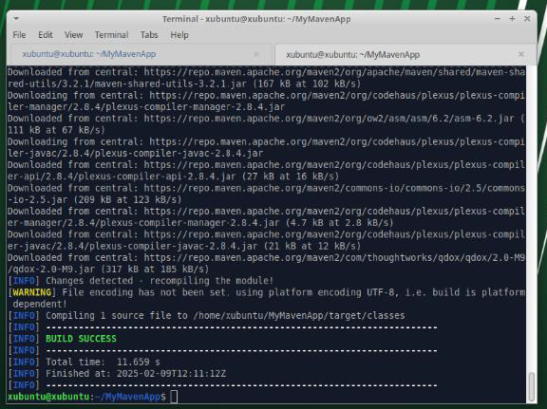

• Run Unit Tests:
mvn test
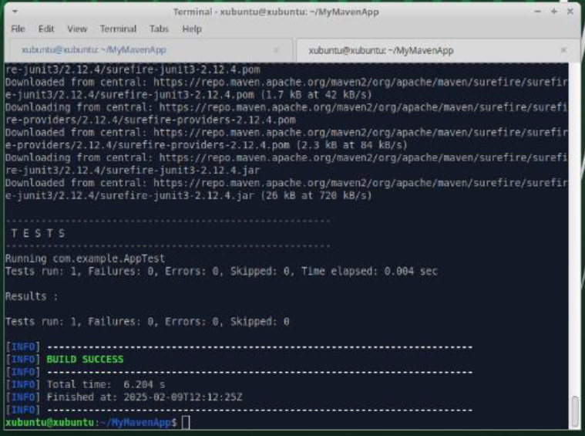

• Package the Application:
mvn package
This command compiles, tests, and packages your code into a JAR file located in the
target directory.
• Clean the Project:
mvn clean
This removes any files generated by previous builds.

